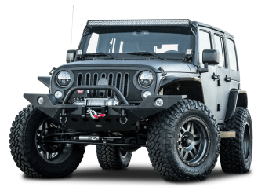

Let’s go for a ride!

**Car Parts**

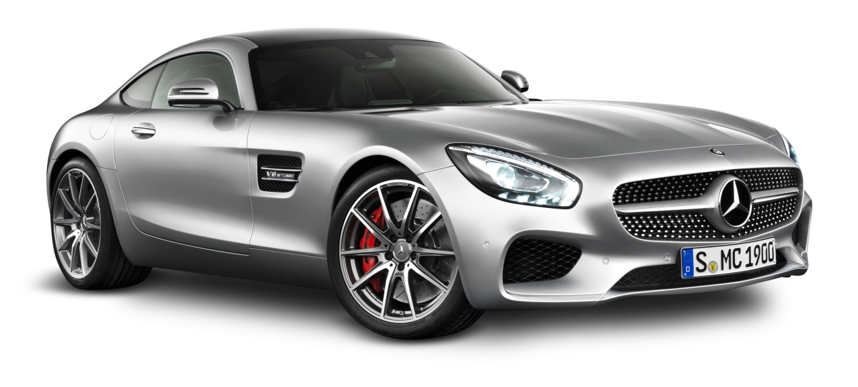

Wiindshield / Windscreen

Door handle

Hood

Wing mirror

License plate

Rearview mirror

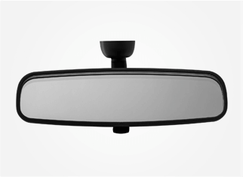

Headlight

Bumper

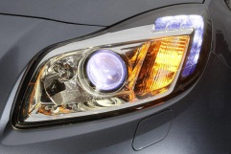

Blinker / Indicator

Windshield wiper

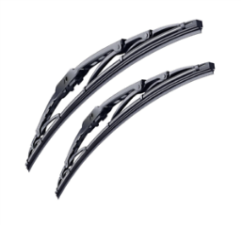

Seat belt

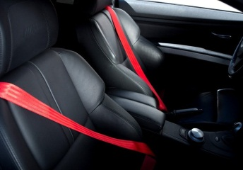

Seat

Wheel

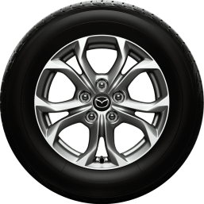

Tire

Engine

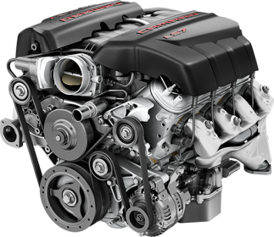

Horn

Accelerator

Brake

Clutch

Steering wheel

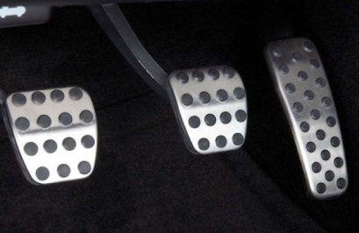

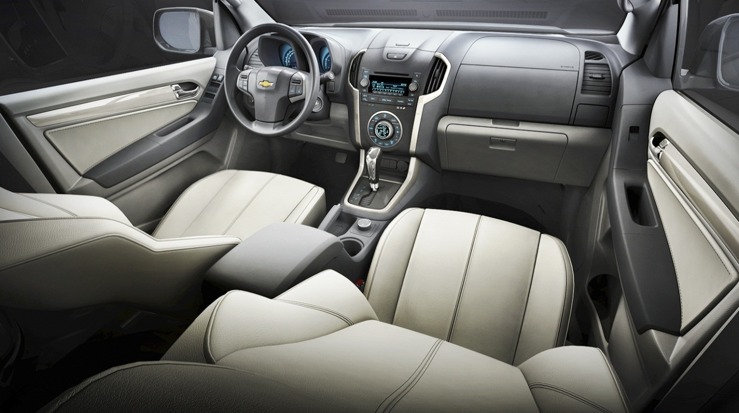

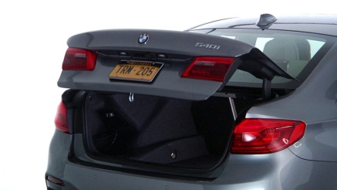

Tail lights

Trunk

Glove compartment

Gear

Engine

Brake

Gear

Glove compartment

Wheel

Accelerator

Windshield wiper

Seat

Horn

Steering wheel

Tire

Windshield

Door handle

Clutch

Hood

Rearview mirror

License plate

Seat belt

Tail lights

Trunk

Blinker / Indicator

Bumper

Headlight

Wing mirror











