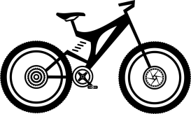

Enjoy the ride!

**Mountain Bike Parts**

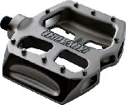

Pedal

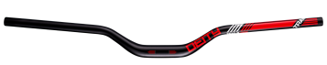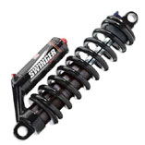

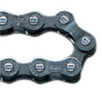

Chain

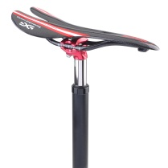

Seat post

Seat / Saddle

Handlebar

Rear suspension

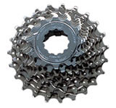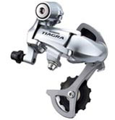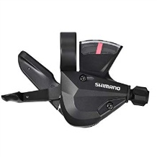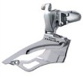

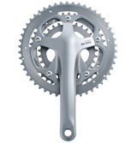

Chainrings

Crankarm

Front derailler

Cassette

Rear derailler

Shifter

Gear

Wheel

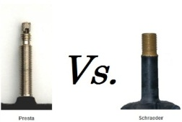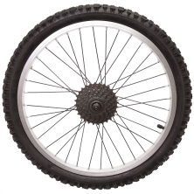

Spokes

Valve

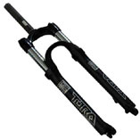

Front suspension

Fork

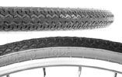

Tire

Rim

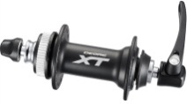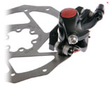

http://www.escoladebicicleta.com.br/manopla.jpg

Grip

Hub

Disc brake

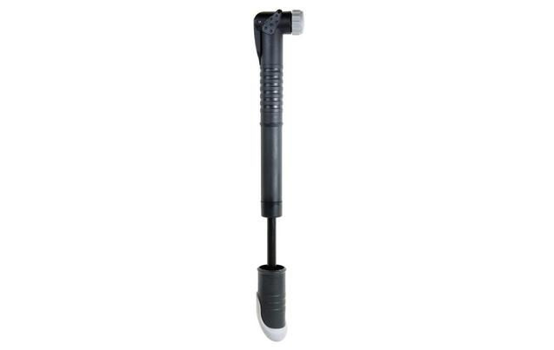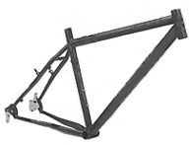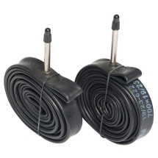

Pump

Inner Tube

Frame

1. Choose the correct option.

Spokes

Front suspension

Rear suspension

Rear derailler

Saddle / Seat

Wheel

Handlebar

Rim

Crank arm

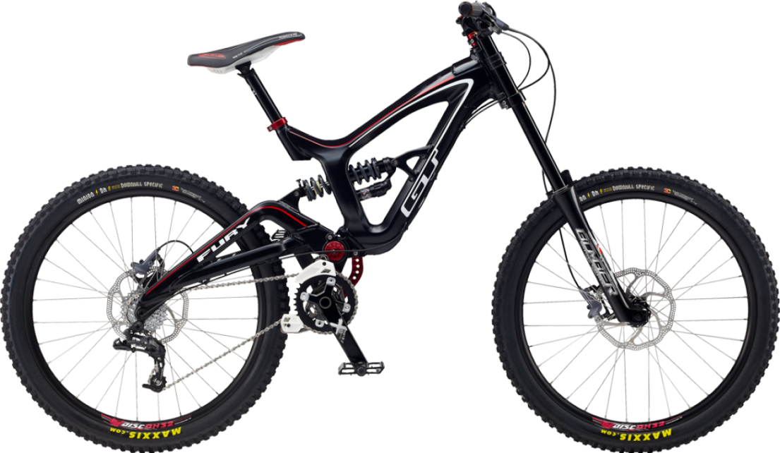

Rear Brake

Front Brake

Chain

Pedal



Cassette

Frame

Pump

Inner Tube

Seat post

Shifter

Crankarm

Front suspension

Fork

